INSTRUCTIONS FOR TYPING MANUSCRIPTS
FOR INGEGNERIA SISMICA
Gianmario Benzoni¹, Fernando Fraternali², Rosario Montuori²
¹Department of Structural Engineering, University of California San Diego, CA, USA
²Department of Civil Engineering, University of Salerno, Fisciano (SA), Italy
SUMMARY: This section should summarize the context, contents and conclusion and should not contain any references or equations. The summary should be limited to 150 words.
KEYWORDS: keyword 1, keyword 2, keyword 3, keyword 4, keyword 5
1 Introduction
Contributions are to be in English. Typeset in 12 pt Times New Roman. Paper format is A4. Paper margins: top = 4cm, bottom = 3cm, left = 2.54cm, right = 2.54cm.
Major headings or section headings should be typeset in 14 pt Times New Roman boldface with the first letter of important words capitalized. Leave one blank lines (12 pt) before and half blank line (6pt) after each heading. The paper length should not exceed 20 pages.
1.1 Sub-headings and sub-subheadings
Typeset in 14 pt Times New Roman boldface and capitalize the first letter of the first word only. Numbers should be in Arabic. Leave one blank lines (12 pt) before and half blank line (6pt) each sub-heading.
2 The Main Text
Line spacing should be single line (12pt) for the entire paper. Lists may be laid out with each item marked by a bullet - point or numbered in lowercase numerals.
- item one
- item two.
3 Equations
Displayed equations should be numbered consecutively, with the number set flush right and enclosed in parentheses. They are to be centered on the page width. Conventional symbols and SI units should be adopted and used consistently.
Equations must be referred to in a complete form, e.g. Equation (1).
$$f\left(x\right)=a_{0}+\sum_{n=1}^{∞}{\left(a_{n}\cos{\frac{nπx}{L}}+b_{n}\sin{\frac{nπx}{L}}\right)+}e^{x}+10+x+\frac{x}{1!}+\frac{x^{2}}{2!}+\frac{x^{3}}{3!}+\frac{x^{4}}{4!}+$$  $$+\frac{x^{5}}{5!} + \frac{x^{6}}{6!} +x^{10} with -∞<x<∞$$ | (1)
Leave one blank line (12 pt) before and after the equation.
3.1 Equations in sub-headings
Equations reported in sub-headings should be numbered consecutively. No reference to the sub-headings is needed:
$$\sin{α}±\sin{β}=2\sin{\frac{1}{2}\left(α±β\right)}\cos{\frac{1}{2}\left(α∓β\right)}$$ | (2)
4 Figures and Tables
4.1 Rules for figures
Figures should be inserted in the text nearest their first reference. Figures are requested in publication quality (JPEG 300 dpi minimum), numbered consecutively and centered on the page width.
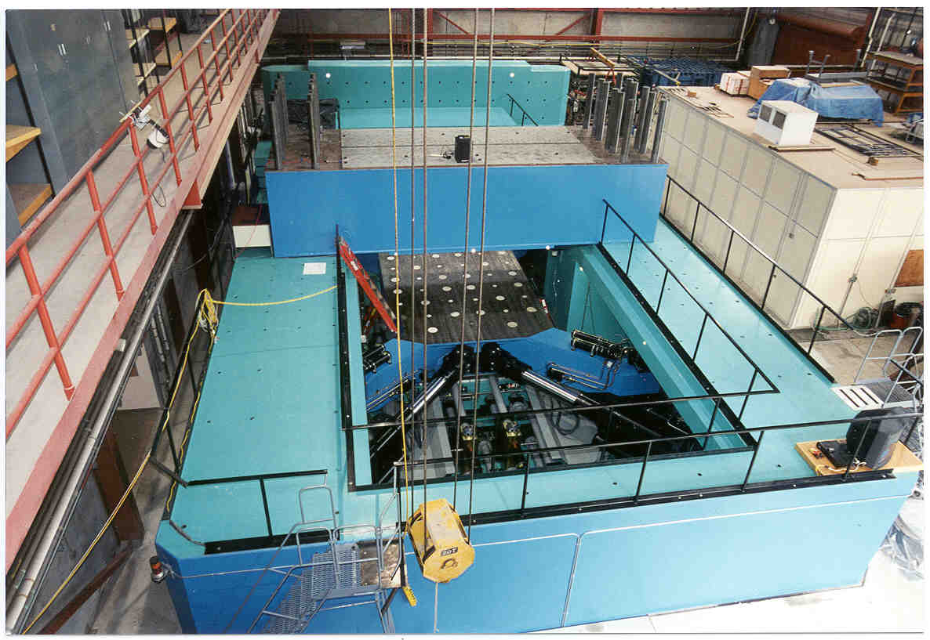
Figure 1 - Testing Equipment
Figures should be referred to in a complete form, e.g. Figure 1 with no reference to sub-headings as for equations. Captions should be placed below the figure, typed in 12 pt Times New Roman, italic. Leave one blank line (12pt) before the caption and after the figure (see example).
4.2 Rules for tables
Same rules for figures apply. Please locate caption above the table as in Table 1.
Table 1 - Main Characteristics of accelerograms
No. | Event | M | CFR  (km) | PGA  (g) | PGV  (cm/s) | PGD  (cm)
1 | Imperial Valley 1979  (H-BRA225) | 6.5 (M) | 8.5 | 0.16 | 35.9 | 22.4
2 | Superstition Hills  (B-WSM090) | 6.7 (M) | 13.3 | 0.17 | 23.5 | 13
5 Acknowledgements
This section (not required) should be placed before the References. Funding information may also be included here.
6 Appendix
Appendices should be used when absolutely necessary. They should be placed before the References. If there is more than one Appendix, number them alphabetically. Please number displayed equations occurring in the Appendix as: (A.1), (A.2), etc.
References
Bibliographical references should be complete, including article titles and page ranges. All references in the bibliography should be cited in the text by author and date set in square brackets: for instance, [Kalkan and Gulkan, 2004, Matsumura, 1992, Pauly and Priestley, 1992] or, for more than two authors [Lomiento et al., 2013]. The bibliography must be ordered by last name of first author. Typeset in 11 pt, Times New Roman according to the following examples:

Kalkan, E., and Gulkan, P. (2004). Site-dependent spectra derived from ground motion records in Turkey. Earthquake Spectra 20, 111-1138.
Lomiento, G., Bonessio, N., Benzoni, G. (2013). Concave sliding isolator's performance under multi-directional excitation. Ingegneria Sismica - International Journal of Earthquake Engineering, XXX(3):17–32.
Matsumura, K. (1992). On the intensity measure of strong motions related to structural failures, Proc. of the 10th World Conference on Earthquake Engineering, Madrid, Spain, 375-380.
Paulay, T. and Priestley, M. N. J. (1992). Seismic Design of Reinforced Concrete and Masonry Buildings. John Wiley & Sons, Inc., New York.

ISTRUZIONI PER L’IMPAGINAZIONE DEI LAVORI DA SOTTOMETTERE A INGEGNERIA SISMICA
Gianmario Benzoni¹, Fernando Fraternali², Rosario Montuori²
¹Department of Structural Engineering, University of California San Diego, CA, USA
²Dipartimento di Ingegneria Civile, Università di Salerno, Fisciano (SA), Italia
SUMMARY: Il sommario breve in italiano dovrebbe riassumere i contenuti e le conclusioni riportate nell’articolo. Non deve contenere riferimenti bibliografici o equazioni.
KEYWORDS: keyword 1, keyword 2, keyword 3, keyword 4, keyword 5
For not Italian authors this page will be provided by the editors.

